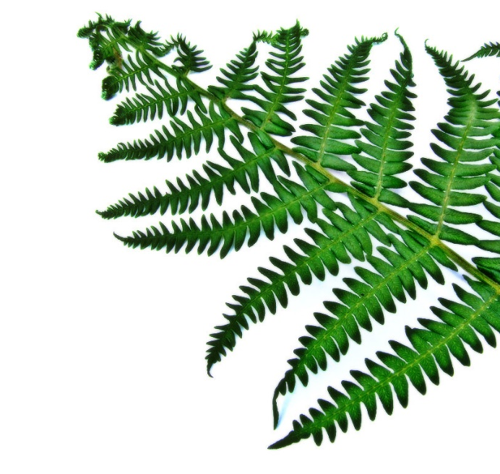

THE CRETACEOUS CAFÉ

MENU

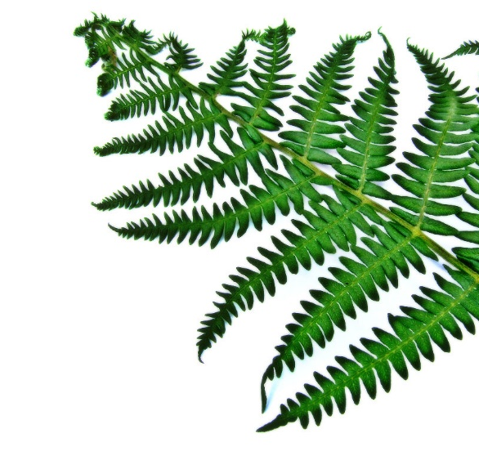
T-REX FINGERS AND DIP
STEGASAURUS STEAKS
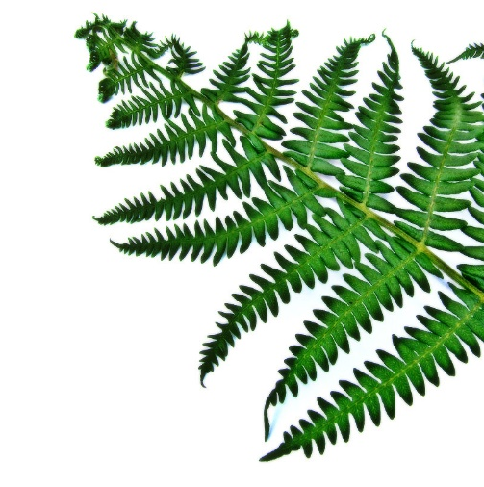
DINO SNACKS (KIDS)

PREHISTORIC POPPING ROCK CAKE

